**VALLIAMMAL COLLGE FOR WOMEN(1363)**

**DEPARTMENT OF COMPUTER SCIENCE WITH DATA SCIENCE**

**PROJECT TITLE : RYTHIMIC TUNES**

**TEAM ID :147562**

**TEAM MEMBERS: 1.KAAVYA S(TEAM LEADER)**

**2.USHARANI G**

**3.RUDHRA ROOPINI P**

**4.PRIYA DHARSHINI R**

**5.HARINI S**

* **GITHUB LINK (CODING AND DOCUMENTATION)**

**https://github.com/SKaavya15/Rythmictunes_kaavya.git**

* + **GOOGLE DRIVE LINK (DEMO VIDEO LINK)**

**https://drive.google.com/drive/my-drive**

1. **INTRODUCTION**

**PROJECT TITLE :** Rythimic Tunes (React)

**TEAM MEMBERS :** Kaavya S( Team leader)

Usharani G

Rudhra Roopnini P

Priya Dharshini R

Harini S

**2. PROJECT OVERVIEW**.

**PROJECT GOALS AND OBJECTIVES**

The primary goal of Music Streaming is to provide a seamless platform for music enthusiasts, enjoying, and sharing diverse musical experiences. Our objectives include:

* **User-Friendly Interface**: Develop an intuitive interface that allows users to effortlessly explore, save, and share their favorite music tracks and playlists.
* **Comprehensive Music Streaming**: Provide robust features for organizing and managing music content, including advanced search options for easy discovery.
* **Modern Tech Stack**: Harness cutting-edge web development technologies, such as React.js, to ensure an efficient and enjoyable user experience while navigating and interacting with the music streaming application.

**KEY FEATURES**

* **Song Listings**: Display a comprehensive list of available songs with details such as title, artist, genre, and release date.
* **Playlist Creation**: Empower users to create personalized playlists, adding and organizing songs based on their preferences.
* **Playback Control**: Implement seamless playback control features, allowing users to play, pause, skip, and adjust volume during music playback.
* **Offline Listening**: Allow users to download songs for offline listening, enhancing the app's accessibility and convenience.
* **Search Functionality**: Implement a robust search feature for users to easily find specific songs, artists, or albums within the app

1. **ARCHITECTURE**

**COMPONENT STRUCTURE**

The component structure of this music streaming application follows a modular and reusable approach to ensure scalability and efficient state management. The root component, App.js, manages routing using React Router and provides global state management through either Context API or Redux. At the top, Navbar.js provides navigation links to the Home, Favorites, and Playlist pages. The Home.js component fetches and displays all songs, utilizing SongList.js to iterate through the list and SongCard.js to render individual songs. Each song card includes details like the song title, singer, genre, and controls for playing, adding to favorites, or adding to a playlist.

The MusicPlayer.js component handles playback actions such as play, pause, next, and previous, and syncs with SongCard.js to display the currently playing song. The Favorites.js component retrieves and displays songs marked as favorites, reusing SongList.js and SongCard.js for consistency. Similarly, the Playlist.js component shows songs that users have added to their playlists, integrating PlaylistManager.js to allow playlist creation and management.

Additionally, SearchBar.js provides functionality for searching songs by title, singer, or genre, filtering the results dynamically in Home.js. The Footer.js component appears at the bottom of the application with general information. The interaction between these components ensures a smooth user experience, with state managed globally to enable seamless transitions between different sections of the application. This structured approach makes it easy to add future features such as a queue system, recommendations, or user-generated playlists

**STATE MANAGEMENT**

For this music streaming application, **Context API** is a suitable state management approach, as it efficiently manages global state while keeping the project lightweight and easy to maintain. The **Context API** allows centralized state management without requiring complex setups like Redux, making it ideal for handling data related to **songs, favorites, playlists, and the currently playing track**.

* **How State Management Works in This Project**
* **Global State Provider (SongContext.js)**:
* A **React Context** is created to store and manage **songs, favorites, playlists, and the current track**.
* This context is wrapped around the entire application in App.js, ensuring that all components have access to the global state.

1. **State Variables Managed in Context:**

* songs: Stores the list of all available songs.
* favorites: Stores the list of favorite songs added by the user.
* playlist: Stores the list of songs added to the user’s playlist.
* currentSong: Tracks the currently playing song for the MusicPlayer.js component.
* isPlaying: Boolean state to control playback status.

1. **Functions for Managing State:**

* addToFavorites(song): Adds a song to the favorites list.
* removeFromFavorites(songId): Removes a song from favorites.
* addToPlaylist(song): Adds a song to the user’s playlist.
* removeFromPlaylist(songId): Removes a song from the playlist.
* playSong(song): Updates currentSong and sets isPlaying to true.
* pauseSong(): Sets isPlaying to false.

1. **Consuming Context in Components:**

* **Home.js**, **Favorites.js**, and **Playlist.js** consume SongContext to display and modify data dynamically.
* **MusicPlayer.js** uses currentSong and isPlaying from the context to control playback.
* **SongCard.js** accesses context functions to handle **adding/removing songs** from favorites and playlists

**ROUTI NG**

**Routing Structure for the Music Streaming App**

This project uses React Router (react-router-dom) to handle navigation, ensuring a seamless experience as users move between different pages. The routing is implemented in App.js, where all paths are defined within a Router and a Routes component.

**Defined Routes and Navigation**

* **Home** - Displays all available songs using a list format.
* **Favorites -** Shows songs that the user has added to their favorites.
* **Playlist -**Displays songs added to the user's custom playlist.
* **Wildcard -**Handles undefined routes and redirects to a "404 Not Found" page.

The Navbar component provides navigation links that allow users to switch between these pages without reloading.

**How Routing Works in the App**

* The Router wraps the entire application to enable navigation between different pages.
* Routes define the available paths and specify which components should be rendered for each URL.
* Navigation Links use <Link> elements instead of traditional <a> tags to ensure smooth navigation without full-page reloads.
* If a user tries to access an undefined route, a Not Found page is displayed to handle errors gracefully.

**Why React Router?**

* Provides client-side navigation without full-page reloads.
* Enables dynamic routing, allowing users to interact with features like favorites and playlists seamlessly.
* Supports scalability, making it easy to add new pages or features in the future.

.**4. SETUP INSTRUCTIONS**

**PRE-REQUISITES**

Here are the key prerequisites for developing a frontend application using React.js:

* **Node.js and npm**:

Node.js is a powerful JavaScript runtime environment that allows you to run JavaScript code on the local environment. It provides a scalable and efficient platform for building network applications.

Install Node.js and npm on your development machine, as they are required to run JavaScript on the server-side.

* + Download: <https://nodejs.org/en/download/>
  + Installation instructions: <https://nodejs.org/en/download/package-manager/>
* **React.js**:

React.js is a popular JavaScript library for building user interfaces. It enables developers to create interactive and reusable UI components, making it easier to build dynamic and responsive web applications.

Install React.js, a JavaScript library for building user interfaces.

* **Create a new React app**:

npm create vite@latest

Enter and then type project-name and select preferred frameworks and then enter

* **Navigate to the project directory**:

cd project-name

npm install

* **Running the React App**:

With the React app created, you can now start the development server and see your React application in action.

* **Start the development server**:

npm run dev

This command launches the development server, and you can access your React app at <http://localhost:5173> in your web browser.

* HTML, CSS, and JavaScript: Basic knowledge of HTML for creating the structure of your app, CSS for styling, and JavaScript for client-side interactivity is essential.
* Version Control: Use Git for version control, enabling collaboration and tracking changes throughout the development process. Platforms like GitHub or Bitbucket can host your repository.
  + Git: Download and installation instructions can be found at: <https://git-scm.com/downloads>
* Development Environment: Choose a code editor or Integrated Development Environment (IDE) that suits your preferences, such as Visual Studio Code, Sublime Text, or WebStorm.
  + Visual Studio Code: Download from <https://code.visualstudio.com/download>
  + Sublime Text: Download from <https://www.sublimetext.com/download>
  + WebStorm:Download from [https://www.jetbrains.com/webstorm/download](https://www.jetbrains.com/webstorm/download%20)

**INSTALLATION**

Installation Guide for the Music Streaming App

Follow these steps to set up the music streaming application on your local machine.

**Step 1: Clone the Repository**

Obtain the repository URL from the version control system (e.g., GitHub, GitLab) and clone it to your local system using the appropriate command-line tool.

**Step 2: Navigate to the Project Directory**

After cloning, open a terminal or command prompt and change the directory to the project folder.

**Step 3: Install Dependencies**

Use the package manager specified in the project (such as npm or yarn) to install all necessary dependencies. This will ensure that required libraries like React, React Router, and any additional dependencies are correctly set up.

**Step 4: Configure Environment Variables**

If the project relies on environment variables (such as API keys, database URLs, or authentication credentials), create a configuration file in the project’s root directory. The required environment variables should be added according to the project's documentation.

**Step 5: Start the Development Server**

Run the appropriate command to start the application in development mode. This will launch the project on a local server, allowing you to access it in a web browser.

**Step 6: Build for Production (Optional)**

If deploying the project, generate a production-ready build using the specified command. The build files can then be hosted on a web server or deployment platform.

**5.FOLDER STRUCTURE**

**CLIENT-SIDE STRUCTURE**

The React application is structured in a way that promotes modularity, scalability, and maintainability. The project follows a clear folder organization, making it easy to manage components, assets, and features.

**Folder Structure Overview**

The main directories inside the client-side of the project include:

* src/ (Source Folder) → Contains all core React files and application logic.
* components/ → Reusable UI components such as buttons, song cards, and the music player.
* pages/ → Contains full-page components like Home, Favorites, and Playlist.
* context/ → Manages global state using React Context API.
* assets/ → Stores static files like images, icons, and audio files.
* routes/ → Defines all routes using React Router for navigation.
* styles/ → Stores global CSS files or styled components for consistent styling.
* utils/ → Contains helper functions or services (e.g., formatting, API calls).

**Detailed Breakdown**

1. components/ (Reusable UI Elements)
   * Navbar: Contains navigation links for Home, Favorites, and Playlist.
   * SongCard: Displays individual song details (title, artist, image).
   * MusicPlayer: Handles audio playback (play, pause, next, previous).
2. pages/ (Full-Page Components)
   * Home: Displays the list of all available songs.
   * Favorites: Shows songs marked as favorites.
   * Playlist: Displays the user’s custom playlist.
   * NotFound: Handles invalid routes with a 404 page.
3. context/ (State Management)
   * SongContext: Manages global state for songs, favorites, and playlists.
4. assets/ (Static Resources)
   * Images: Stores album covers and UI icons.
   * Audio Files: Stores locally hosted song files if required.
5. routes/ (Routing Configuration)
   * Defines all application routes using React Router.
6. styles/ (Styling)
   * Contains CSS, SCSS, or styled-components for design consistency.
7. utils/ (Helper Functions)
   * Stores functions for formatting song duration, handling API requests, etc

**Utilities in the Music Streaming App**

The project includes various helper functions, utility classes, and custom hooks to improve efficiency, reusability, and maintainability. These utilities handle formatting, API interactions, and state management to simplify development.

**Utility Functions (utils/ Folder)**

This folder contains standalone functions that help with data processing, formatting, and other repetitive tasks.

1. formatTime.js → Converts song duration from seconds to a MM:SS format.
2. filterSongs.js → Filters songs based on genre, artist, or user input.
3. localStorageHelper.js → Manages saving and retrieving user data (e.g., favorites, playlists) from local storage.

**Custom Hooks (hooks/ Folder - If Used)**

Custom hooks simplify and reuse complex logic within functional components.

1. useAudioPlayer.js
   * Manages audio playback (play, pause, next, previous).
   * Controls volume, playback speed, and track progress.
2. useFetchSongs.js
   * Fetches song data from an API or local JSON file.
   * Handles loading and error states.

**Utility Classes (If Styled Components or CSS Modules are Used)**

* styles/helpers.css → Contains global CSS utility classes for spacing, typography, and reusable styles.
* theme.js (if using styled-components) → Manages light/dark themes and global styles.

**6.RUNNING THE APPLICATION**

1. **Start the Frontend Server**

* Navigate to the frontend directory.
* Run the command to start the development server.
* The application will be accessible in your browser.

1. **Start the Backend Server** (If applicable)

* Navigate to the backend directory.
* Start the backend server using the appropriate command.
* The backend will run on the configured port.

**7.COMPONENT DOCUMENTATION**

**KEY COMPONENT**

**Component Documentation**

**1. SongCard**

**Purpose:**

Displays an individual song with its image, title, singer, and an option to play or add to favorites.

**Props:**

* id (number) – Unique song identifier.
* title (string) – Song title.
* singer (string) – Singer’s name..
* imgUrl (string) – URL of the song’s cover image.
* songUrl (string) – URL of the song file.
* onPlay (function) – Callback to play the song.
* onFavorite (function) – Callback to add/remove from favorites.

**2. SongList**

**Purpose:**

Renders a list of songs, used for displaying all songs, playlists, or favorites.

**Props:**

* songs (array) – List of songs to display.
* onPlay (function) – Function to handle song play.
* onFavorite (function) – Function to handle adding/removing favorites.

**3. Player**

**Purpose:**

Handles song playback controls such as play, pause, and skip.

**Props:**

* currentSong (object) – The song currently playing.
* isPlaying (boolean) – Indicates if a song is playing.
* onPlayPause (function) – Toggles play/pause.
* onNext (function) – Skips to the next song.
* onPrevious (function) – Goes back to the previous song.

**4. Favorites**

**Purpose:**

Displays a list of favorite songs.

**Props:**

* favorites (array) – List of favorite songs.
* onRemoveFavorite (function) – Removes a song from favorites.

**5. Playlist**

**Purpose:**

Shows a custom playlist created by the user.

**Props:**

* playlist (array) – List of songs in the playlist.
* onRemoveFromPlaylist (function) – Removes a song from the playlist.

**6. SearchBar**

**Purpose:**

Allows users to search for songs.

**Props:**

* onSearch (function) – Handles search input.

**Reusable Components Documentation**

Below are the key **reusable components** in your music streaming application, along with their purpose and configurations.

**1. Button**

**Purpose:**

A reusable button used across the app for actions like play, pause, add to favorites, etc.

**Props:**

* label (string) – The text to display on the button.
* onClick (function) – Callback function triggered on click.
* variant (string) – Defines the button style (e.g., "primary", "secondary").
* icon (ReactNode, optional) – Optional icon to display inside the button.
* disabled (boolean) – Disables the button when true.

**2. IconButton**

**Purpose:**

A small button with an icon, used for actions like play, pause, next, and favorite.

**Props:**

* icon (ReactNode) – The icon to display inside the button.
* onClick (function) – Function triggered when clicked.
* size (string, optional) – Size of the button ("small", "medium", "large").
* disabled (boolean) – Disables the button when true.

**3. Card**

**Purpose:**

A container for displaying a song’s image, title, and artist details. Used in SongList, Favorites, and Playlist.

**Props:**

* imgUrl (string) – The image URL for the card.
* title (string) – The song title.
* subtitle (string) – Additional info (e.g., singer name).
* onClick (function) – Function to handle click action.

**4. AudioPlayerControls**

**Purpose:**

A component to handle media controls like play, pause, next, and previous.

**Props:**

* isPlaying (boolean) – Indicates if a song is currently playing.
* onPlayPause (function) – Toggles play and pause.
* onNext (function) – Skips to the next song.
* onPrevious (function) – Goes back to the previous song.

**5. Modal**

**Purpose:**

A generic popup modal used for actions like confirming song removal from a playlist.

**Props:**

* isOpen (boolean) – Controls modal visibility.
* onClose (function) – Closes the modal.
* title (string) – Modal title.
* content (string) – Message or content inside the modal.
* onConfirm (function) – Action performed on confirm button click.

**6. InputField**

**Purpose:**

A reusable input field for searching songs or creating playlists.

**Props:**

* placeholder (string) – Text inside the input when empty.
* value (string) – Current input value.
* onChange (function) – Handles text changes.
* type (string) – Type of input ("text", "password", etc.).

**7. Loader**

**Purpose:**

A spinner or loading indicator shown while data is being fetched.

**Props:**

* size (string) – Defines the loader size ("small", "medium", "large")

**8.STATE MANAGEMENT**

**GLOBAL STATE**

**State Management in the Music Streaming Application**

**1. Global State Management**

The application utilizes a global state management approach to handle shared data, ensuring that different components access and update the state efficiently.

**a. State Management Approach**

* **React Context API / Redux / Zustand**: One of these state management solutions is used to store and manage global application state.
* **Local Storage / Async Storage**: Used to persist user preferences, favorites, and playlist selections.
* **API Integration**: The global state is updated dynamically based on API responses.

**b. Key State Objects**

* **Songs (items)**: Stores all available songs, including their metadata such as title, singer, genre, image, and song URL.
* **Favorites (favorities)**: Contains a list of user-favorited songs, allowing quick access to preferred tracks.
* **Playlists (playlist)**: Manages user-created playlists for personalized music collections.
* **Currently Playing (currentSong)**: Tracks the song being played and its progress.
* **Playback State (playerState)**: Manages play, pause, and seek functionalities.

**2. State Flow Across the Application**

**a. Initial Data Loading**

* The song list is fetched from a backend or local JSON file when the application loads.
* Favorite songs and playlists are retrieved from local storage or an API.

**b. Updating State**

* **Adding to Favorites**: When a user marks a song as a favorite, it is added to the favorities state and stored persistently.
* **Adding to Playlist**: A selected song is added to playlist, and the UI updates accordingly.
* **Song Playback Management**:
  + When a user plays a song, currentSong is updated.
  + playerState is updated to reflect play/pause actions.
  + Playback progress is managed to track song duration and user interactions (seek, repeat, shuffle).

**c. State Sharing Between Components**

* **Navigation & UI Components**: Global state allows different screens (e.g., Home, Favorites, Playlist) to access the same song data without reloading.
* **Music Player Component**:
  + Reads currentSong and playerState to display the current track.
  + Updates state when the user changes songs.
* **User Preferences & Storage**:
  + Updates persist when a user logs out or refreshes the page.

**3. Recommended State Management Library**

Depending on the complexity of the application, you can use:

* **React Context API** (For lightweight state management)
* **Redux Toolkit** (For structured, scalable state management)
* **Zustand** (For minimal and efficient state handling

**LOCAL STATE**

**Local** **State Management in the Music Streaming Application**

In addition to global state management, local state is used to handle component-specific behaviors that do not need to be shared across the application. Local state ensures that components remain responsive and dynamic without unnecessary global updates

Local State Management in the Music Streaming Application

In addition to global state management, local state is used to handle component-specific behaviors that do not need to be shared across the application. Local state ensures that components remain responsive and dynamic without unnecessary global updates

**9.STYLING**

**1. CSS Frameworks & Libraries**

The application uses the following styling solutions:

* **Tailwind CSS** (Primary Choice) – A utility-first CSS framework for fast and responsive design without writing extensive custom styles.
* **Styled-Components** (Alternative for React Projects) – Allows scoped component-level styling in JavaScript, avoiding global CSS conflicts.
* **Sass/SCSS** (If Used) – Enhances maintainability with variables, nesting, and mixins for reusable styling patterns.

Each of these approaches ensures a clean, modular, and maintainable styling system.

**2. Theming & Custom Design System**

* **Light & Dark Mode Support:** The app provides theme toggling to enhance user experience based on preferences.
* **Custom Design Tokens:** Colors, typography, and spacing are standardized across the UI for consistency.
* **Responsive Design:** Ensures the app adapts to different screen sizes, improving usability on mobile and desktop.
* **Component-Based Styling:** Reusable UI components ensure a cohesive look and feel throughout the application

**10. TESTING**

**TESTING STRATEGY**

The application follows a structured testing approach to ensure reliability and a smooth user experience. It includes **unit testing, integration testing, and end-to-end (E2E) testing** using

**Testing Frameworks & Libraries**

* **Jest:** Primary testing framework for unit and integration tests.
* **React Testing Library:** Ensures accessibility and proper UI behavior.
* **Mock Service Worker (MSW):** Mocks API requests for integration testing.
* **Cypress/Playwright:** Automates UI tests to replicate user actions.

**CODE COVERAGE**

To ensure the reliability and robustness of the application, test coverage is monitored to assess how much of the code is tested. The goal is to cover critical functionalities, including UI components, state management, and API interactions.

**11.SCREENSHOTS AND DEMO**

**Hero components**

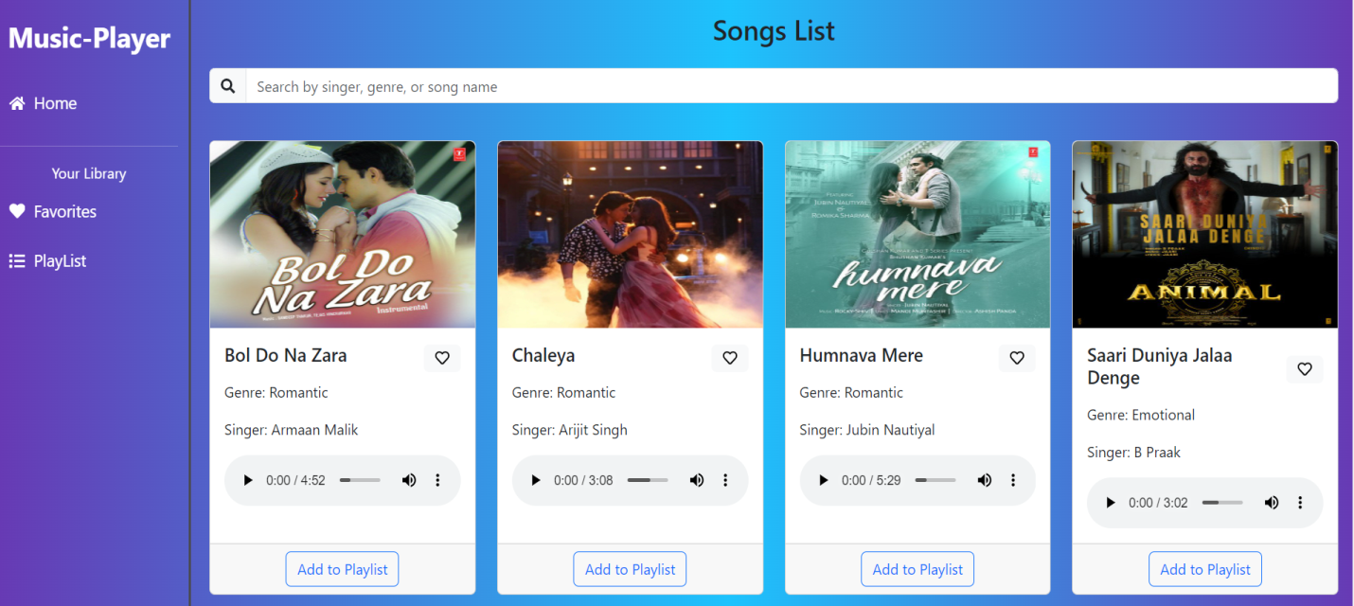

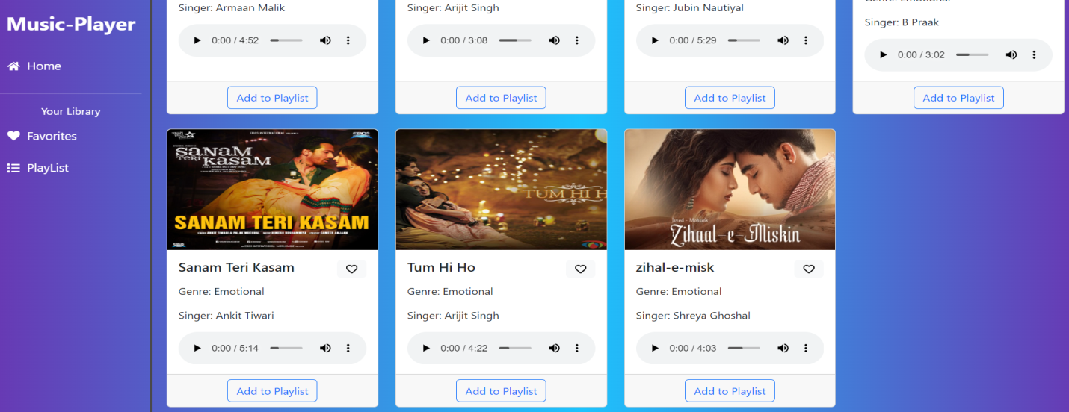

**Playlist**

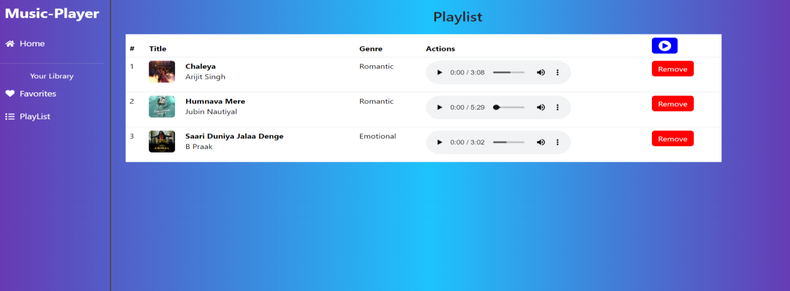

**Favorites**

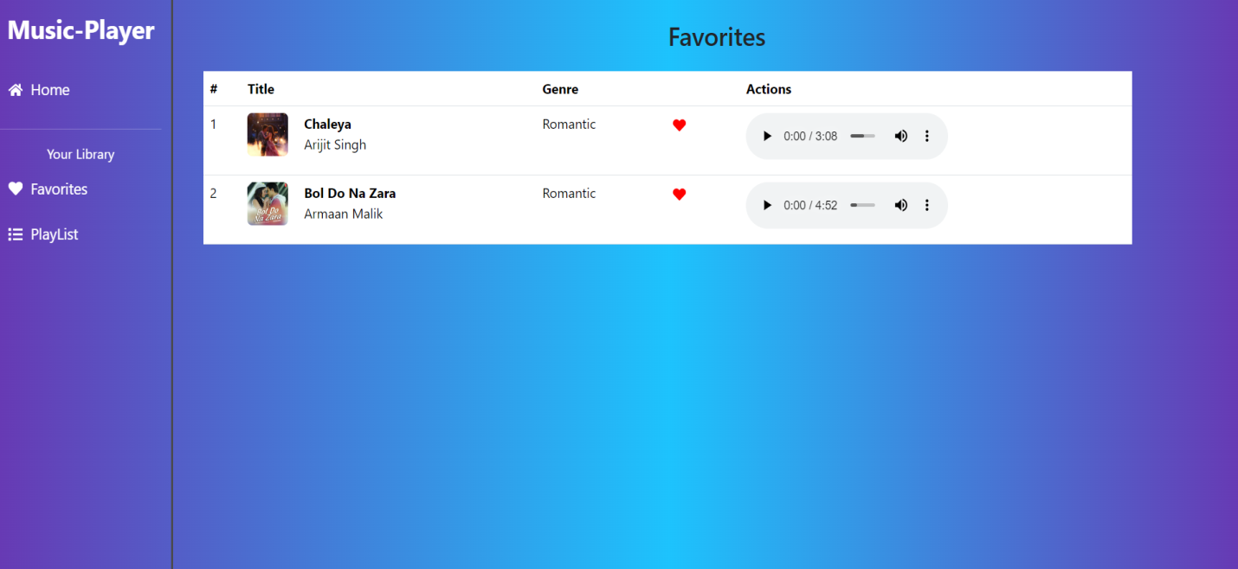

**Project Demo link:**

<https://drive.google.com/file/d/1zZuq62lyYNV_k5uu0SFjoWa35UgQ4LA9/view?usp=drive_link>

**12.KNOWN ISSUES**

Below are the currently known bugs and issues in the music streaming application that users and developers should be aware of.

**1. UI & UX Issues**

* **Playback Controls Lag:** Sometimes, the play/pause button takes a second to respond, especially on slower networks.
* **Mobile Responsiveness Glitches:** Some UI elements may not align properly on smaller screens, especially in the playlist view.
* **Dark Mode Inconsistencies:** Certain text elements may not contrast well in dark mode, affecting readability.

**2. Functional Issues**

* **Song Playback Delay:** There can be a short delay when loading a song due to slow API responses or caching issues.
* **Favorites Not Updating Instantly:** When a user adds or removes a song from favorites, the UI doesn’t reflect the change immediately (requires a page refresh).
* **Search Functionality Bug:** The search bar sometimes doesn’t return results until the full song title is entered.
* **Playlist Duplication Issue:** Some users report that the same song appears multiple times in a playlist after adding it.

**3.Backend & API Issues**

* **Slow API Response:** Fetching song lists or user favorites may take longer than expected, especially during high traffic.
* **Caching Problems:** Songs may not update properly in the UI if they are cached incorrectly.
* **Unauthorized Access Issue:** In some cases, non-logged-in users can access playlist data, which needs proper authentication handling.

**13.FUTURE ENHANCEMENT**

**1. UI/UX Improvements**

* Animated transitions & microinteractions
* Advanced dark mode customization
* Better mobile responsiveness
* Lyrics display

**2. Functional Enhancements**

* Offline mode
* Smart recommendations (AI-based)
* Crossfade & gapless playback
* Queue management
* Equalizer settings

**3. Social & Community Features**

* User profiles & playlist sharing
* Comments & reactions on songs
* Live listening parties

**4. Performance & Backend Enhancements**

* Improved API caching
* Server-side rendering (SSR) for SEO
* Better authentication & security (OAuth, MFA)